805M Monoblock Amplifier Manual.

Congratulations on your purchase of the AM Music 805M, Pure Class A, Single Ended Monoblocks. You are now the owner of one of the World’s finest amplification systems at anywhere near its price. This amplifier is the culmination of 14 years of careful research and development.
Unpacking and assembly:
Carefully remove the amplifier components from their cartons. They are very heavy and care should be taken to not damage the amplifier or cause you injury in lifting them. Carefully unpack the 805 tube. The tube mount is a single pin bayonet fitting. Fit the tube and turn it to the right in a clockwise motion, as far as it will go. Ensure the two input tubes are matched up to the correct pins and gap and push them firmly home. When fitting, or removing the tubes with a Bakelite base, hold the base, or you could break the glass bottle from the base.
WARNING.If your amplifier is fitted with a top cap, there is high voltage present at the top capswhen the amplifier is switched on. This voltage can be extremely dangerous, and if the cap is removed or tampered with when in operation, a severe electric shock is possible. The voltage drops to zero as soon as the power is switched off and the green operating light is off. Ensure that the power is off and the power lead is removed before attempting to remove or access the tube.

On/off switch:
The on/off switch of each amplifier is central on the front of each amplifier.
Connection:
Connect the amplifier to your Hi Fi System. If in doubt as to whether to use the 4 or 8 ohm taps on the amplifier, start with the 8 ohm. Just because a speaker is rated at 4, 6 or 8 ohms does not necessarily mean that is the load seen by the amplifier when playing music. When the amplifier has been biased and is warm, listen to some music and then connect to the 4 ohm taps and listen to the same piece again. The one that sounds fuller, stronger and more musical is the correct setting. Having it on the incorrect taps will not damage the speakers or the amplifier.Most speakers, with this amplifier will sound a lot better on the 4 ohm taps.

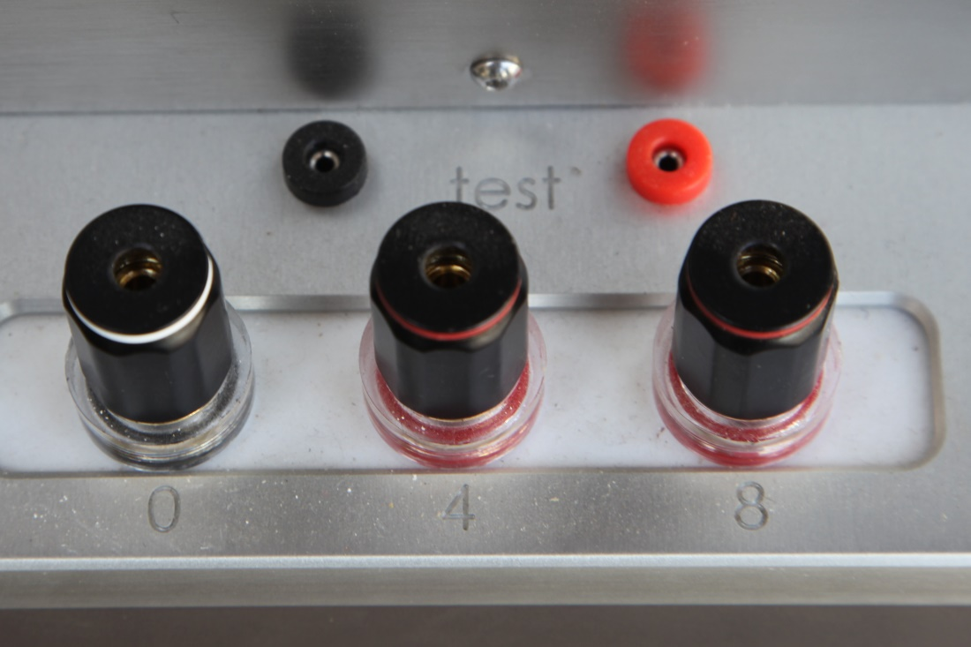
Biasing:The biasing on the amplifier was reduced prior to shipping as a safety measure. Once the amplifier has been on for a while and is fairly warm, connect a Multimeter to the red and black biasing terminals on the top of the amplifier, in between the transformer housing and the speaker terminals. (Shown above)
Set the Meter on DC Volts, and adjust the screw on the rear of the amplifier (Shown below) until it reads between 1 and 1.2V.Or between 100 and 120 mA.
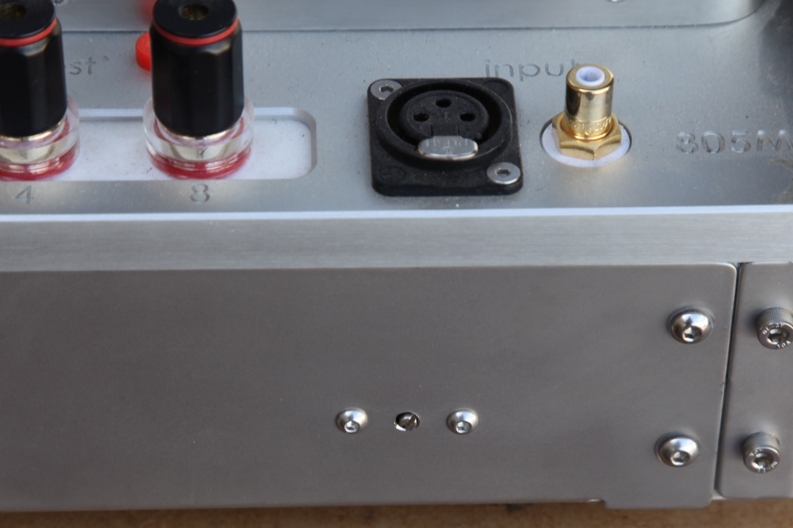
Repeat on the other amplifier.
After about a month or more of running, or about 200 hours, check and reset the bias. After this, there is no real need to keep checking it, unless the tube is replaced, as the bias willnaturally drift as the tube ages.

These amplifiers give off quite a lot of heat, so please ensure that each one has adequate ventilation.
Note: bias adjusting screw on the rear of the amplifier, below the XLR input..
SAFETY INSTRUCTIONS
To avoid personal injury or damage to equipment, please ensure that you read this manual in itsentirety before attempting to operate the equipment. Please retain this manual for future reference.
TO PREVENT THE RISK OF ELECTRIC SHOCK, DO NOT UNDER ANY
CIRCUMSTANCES REMOVE ANY PARTS OF THE EQUIPMENT COVER. THERE ARE NO
USER SERVICEABLE PARTS INSIDE. ALL SERVICING MUST BE CARRIED OUT BYQUALIFIED SERVICE PERSONNEL.
WARNING: Do Not Disassemble. Do not attempt to service the equipment beyond that described in this manual. Touching the equipment’s internal parts could result in severe personalinjury. All other servicing or problems as listed below should be referred to qualified AM service technicians:
* The power supply cord or plug has been damaged
* Objects have fallen or liquid has been spilled into the equipment
* The equipment does not appear to function normally or exhibits a marked change in performance.
* The equipment has been dropped or the enclosure damaged. Do not under any circumstances allowanyone to modify your AM equipment without first checking with AM, yourdealer, or your distributor. Unauthorized modifications will invalidate your guarantee.
Power Source: The equipment should be connected to a power supply only of the type described in this manual oras marked on the equipment.
* Power supply cords should be routed so that they are not likely to be walked on or pinched byitems placed upon or against them, paying particular attention to cords and plugs, and the point where they exit from the amplifier. A quality power cord will make a surprising improvement to the sound quality.

Ventilation: The equipment should be situated so that its location or position does not interfere with its properventilation. These units generate quite a lot of heat. Poor ventilation could/will result in overheating and equipment failure.
* The equipment must not be placed on bed, sofa, or similar surfaces that may block the
ventilation openings.
* The equipment must not be placed in a built-in installation, such as a bookcase or cabinet that mayimpede the flow of air.
* The equipment should be situated away from heat sources such as radiators, heat register, stoves,or other electronic appliances that produce heat. This equipment is not intended for commercialuse.
Water and Moisture: The equipment should not be used near water, e.g. near a bathtub, washbowl, kitchen sink,laundry tub, in a wet basement, or near a swimming pool etc. Similarly, do not placed objectsfilled with liquid, such as vases on top of the equipment.

Lightning: All hi-fi system can be damaged by lightning. Power amplifiers are particularly at riskand therefore should be turned off when there is risk of lightning strike. For complete protectionall mains plugsshould be disconnected when not in use.
Cleaning:Never clean with furniture polish, benzene, or volatile liquids. Dust periodically with a clean, softpaint brush. Fingerprints or other marks can be removed with a moist polishing cloth.
Data specifications:
Tube complement | 6V6 or 6v6 as the drivers, ECC88 as the amplifiers. PSVANE 805 Power
Frequency response | 20Hz-55KHz
Input sensitivity | 1V
S / N | > 90dB
Input selections | RCA single-ended ; balanced / XLR
Power Output | 50w/Ch
Load impedance | 4 & 8 ohms
Power consumption | 180W(each)
Power supply | 100,110,120,220,230,240 VAC 50-60Hz
Dimensions (W * D * H) | 260 X 460 X 220 (mm)
Weight | 31kg (each...
Warranty:
The warranty on all AMproducts is two years parts and labor. The amplifier must be returned to the factory, or to the dealer from which it was purchased, or to a repairer authorized by the factory or the dealer. The warranty on tubes is 3 months from purchase. If a tube lasts 3 months, then it is most likely to last the normal life cycle.
Please contact your dealer if you have any other questions or if you would like any information on other AM products.
AM wishes you many years of very happy listening. Thank you.

